University of Engineering and Technology
Lahore

(AI-133) Programming Fundamentals
Spring 2025

Project Name: Level Devil Flapping bird.



Submitted by

Muhammad Awais Akram
2025(S)-A-AI-21
Fiza Noor
2025(S)-A-AI-08

to

Maam Abqa
1st July, 2025

Main Idea.
Level Devil Gameplay: Game DescriptionLevel Devil Gameplay is a 2D console-based platformer developed in C++, where players control an "@" character navigating through two challenging levels. The objective is to reach the exit while avoiding dynamic obstacles like holes, a moving train, and a falling rock, and collecting coins for points. With simple arrow-key controls (left, right, jump), players test their reflexes and timing. The ASCII-art style, color changes, and beeps create an immersive retro experience. Coins at fixed positions add 10 points each, displayed as "Money." The game features real-time input, collision detection, and modular C++ code, showcasing the developer’s skills in console-based game design. Ideal for casual gamers and retro enthusiasts, Level Devil offers engaging gameplay and high replayability, demonstrating technical proficiency in a resource-constrained environment.
Main Function.
This C++ code segment sets up the core structure of "Level Devil Gameplay," a 2D console-based platformer. It includes necessary headers (iostream, windows.h, conio.h) for console operations and input, declares global variables x=15 and y=15 for the player’s starting position, and lists functions for game mechanics like movement, maze rendering, and obstacle handling. The main function initializes Level 1 by clearing the console, setting a red-on-black color scheme, drawing the maze, placing coins, and displaying "LVL 1." It runs a game loop that handles player movement, coin collection (adding 10 points per coin, shown as "Money"), and checks for holes, falls, or the exit (x=113–114, y=15). Upon reaching the exit, it displays a transition message and moves to Level 2 by calling lvl2(). This code establishes the game’s foundation, managing setup, player interaction, and progression for Level 1.
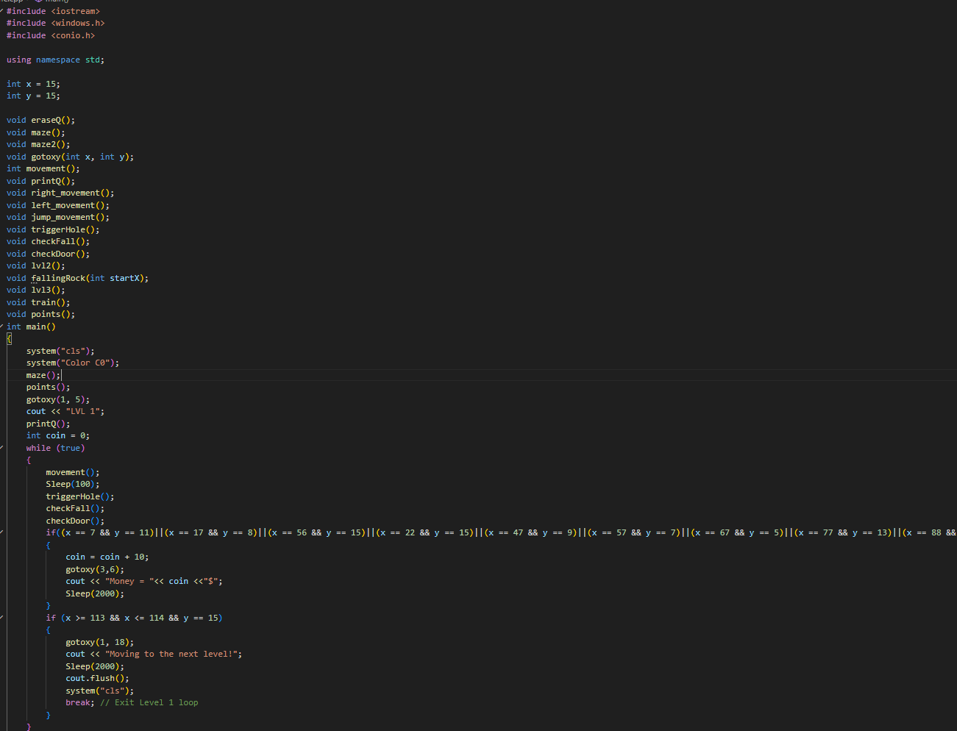

Level Devil Gameplay: Points, Maze, and Gotoxy Functions Description.
This C++ code segment defines three functions—points(), maze(), and gotoxy()—critical to the visual setup and scoring system of "Level Devil Gameplay," a 2D console-based platformer. These functions handle the placement of collectible coins, rendering of the Level 1 game environment, and precise cursor positioning in the console, respectively, contributing to the game’s core presentation and interactivity.points() Function:
The points() function places 11 collectible coins, represented by the "$" symbol, at specific coordinates in the Level 1 maze: (7,11), (17,8), (56,15), (22,15), (47,9), (57,7), (67,5), (77,13), (88,12), (99,14), and (109,10). Using the gotoxy() function, it positions the cursor at each location and outputs "$". These coins serve as collectibles that, when reached by the player, add 10 points to the score, displayed as "Money" in the game loop. This function is called during Level 1 initialization to set up the scoring elements, encouraging exploration and rewarding player progress.maze() Function:
The maze() function renders the visual layout for Level 1. It uses gotoxy() to position the cursor and prints ASCII characters to create a bordered game area. At the top (y=1–3), it displays a header with ":>>>>...>>>>:" borders and the title "LEVEL DEVIL GAMEPLAY" centered within. At y=14–15, it draws a right-aligned door ("|+-+|"), representing the level’s exit. At y=16, a solid line of "=" characters forms the floor. This function establishes the static environment where the player navigates, providing a clear and structured play area.gotoxy(int x, int y) Function:
The gotoxy() function is a utility that moves the console cursor to specified (x, y) coordinates using Windows API functions from <windows.h>. It creates a COORD structure, sets its X and Y values, and calls SetConsoleCursorPosition to update the cursor’s position. This function is essential for precise rendering of game elements like the player ("@"), coins ("$"), and maze components, enabling dynamic updates to the console display without redrawing the entire screen.Role in the Game:
These functions collectively set up the visual and interactive foundation of Level 1. gotoxy() ensures accurate placement of all game elements, maze() creates the static game environment, and points() adds collectible coins to drive the scoring mechanic. Together, they provide the structure for player navigation and engagement, making the game visually coherent and interactive within the console’s constraints.Conclusion:
The points(), maze(), and gotoxy() functions are pivotal for rendering Level 1’s environment and collectibles in Level Devil Gameplay. By handling coin placement, maze drawing, and cursor positioning, they enable a functional and visually clear platformer experience, showcasing the developer’s ability to manage console-based rendering and game setup effectively.
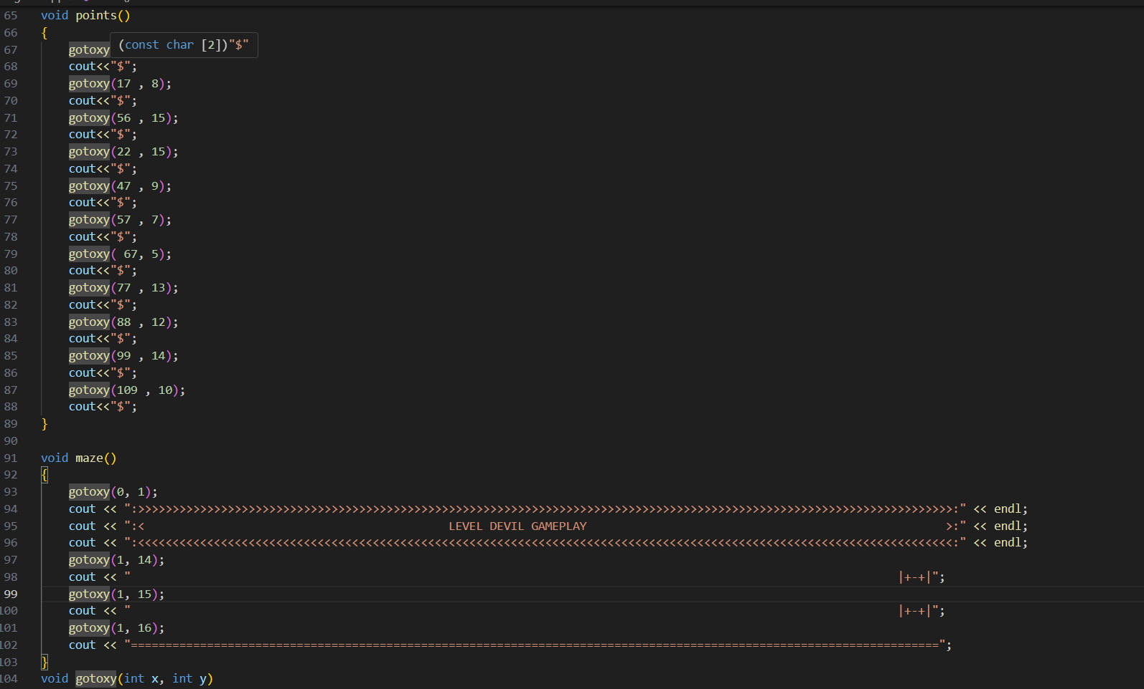
Level Devil Gameplay: Movement Functions Description
This C++ code segment defines the player movement mechanics for "Level Devil Gameplay," a 2D console-based platformer. It includes the movement(), eraseQ(), printQ(), right_movement(), left_movement(), and jump_movement() functions, which handle keyboard input and control the player’s "@" character movement in the game’s console environment.movement(): Checks for Left, Right, or Up Arrow key presses using GetAsyncKeyState and calls left_movement(), right_movement(), or jump_movement() accordingly, enabling real-time player control.eraseQ(): Clears the player’s current position by printing a space at coordinates (x, y) using gotoxy(), preventing visual overlap during movement.printQ(): Draws the player’s "@" symbol at the current (x, y) coordinates using gotoxy(), updating the player’s position on-screen.right_movement(): Moves the player right by clearing the current position, incrementing x, and redrawing the player.left_movement(): Moves the player left by clearing the current position, decrementing x, and redrawing the player.jump_movement(): Simulates a jump by moving the player up (decrementing y), pausing briefly with Sleep(100), allowing additional inputs, then returning the player down (incrementing y).Role: These functions enable responsive left, right, and jump movements, allowing the player to navigate the maze, avoid obstacles, and collect coins. They ensure smooth visuals by clearing and redrawing the player, forming the core of player interaction.Conclusion: This code powers the dynamic movement system in Level Devil Gameplay, showcasing real-time input handling and console-based rendering for an engaging platformer experience.
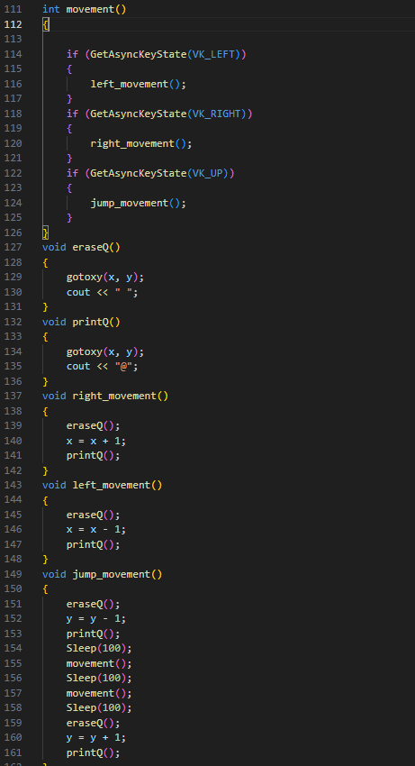
Level Devil Gameplay: Hole-Related Functions Description
This C++ code segment defines the triggerHole(), isHoleBelow(), and checkFall() functions for "Level Devil Gameplay," a 2D console-based platformer. These functions implement a dynamic trap mechanic in Level 1, where holes open in the floor based on the player’s position, potentially causing a game-over scenario if the player falls.triggerHole(): Activates holes in the floor when the player’s x-coordinate is near specific positions. If x == 19, it clears a space at (22, 16) to open a hole; if x == 53, it clears a space at (56, 16). This modifies the maze dynamically, creating traps under the player.isHoleBelow(): Returns true if the player is directly above an open hole (at x == 22 or x == 56), used to check if the player is at risk of falling.checkFall(): Checks if the player is at y == 15 (ground level) and above an open hole (isHoleBelow()). If true, it animates a fall by incrementing y three times, clearing and redrawing the player ("@") with eraseQ() and printQ(), changing the console color to red-on-white (system("Color 74")), and playing a 500 Hz beep for 300ms. After the fall, it displays a game-over message at (1, 10), pauses for 2 seconds, and waits for a keypress. Pressing ESC (key == 27) exits the game; any other key resets the player to (1, 15), redraws the maze, and restarts Level 1.Role: These functions create a dynamic hazard system, making the floor treacherous at specific points. They enhance challenge and strategy by requiring careful movement to avoid falling, with visual and audio feedback for immersion.Conclusion: The triggerHole(), isHoleBelow(), and checkFall() functions add a critical trap mechanic to Level Devil Gameplay, increasing difficulty and engagement through dynamic obstacles and a polished game-over sequence.
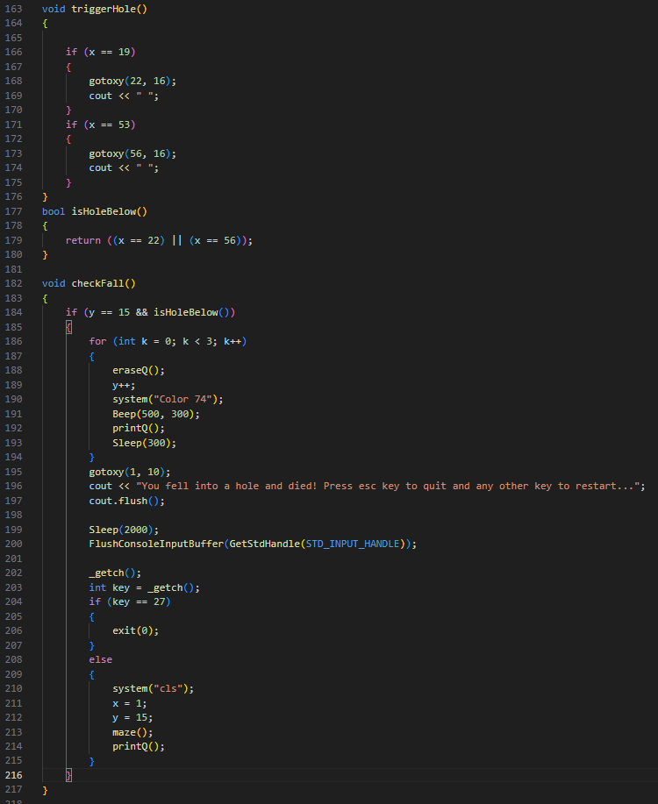

Void train and void check door.
Level Devil Gameplay: Door and Train Functions DescriptionThis C++ code segment defines the checkDoor() and train() functions for "Level Devil Gameplay," a 2D console-based platformer. These functions manage level progression and a dynamic obstacle in Level 2, enhancing gameplay with a transition mechanism and a hazardous moving element.checkDoor(): Monitors if the player reaches the exit door at coordinates (x=113–114, y=14) in Level 1. If true, it uses gotoxy(1, 18) to display "Moving to the next level!" at the bottom of the screen, changes the console color to purple-on-pink (system("Color D5")), pauses for 2 seconds (Sleep(2000)), clears the output buffer (cout.flush()), and clears the screen (system("cls")). This signals the transition to Level 2, preparing the game for the next stage.train(): Implements a moving obstacle in Level 2, represented by "###" at y=15. It loops through x-coordinates from 1 to 113 (tx), drawing the train at each position with gotoxy(tx, ty) and cout << "###", then erasing it with spaces after a 50ms pause (Sleep(50)). If the train’s leading edge (m = tx + 3) collides with the player’s position (x, y), it displays a game-over message at (1, 10), pauses for 1 second, and waits for a keypress. Pressing ESC (key == 27) exits the game; any other key clears the screen and restarts Level 2 by calling lvl2().Role: checkDoor() facilitates progression from Level 1 to Level 2 with clear visual feedback, while train() introduces a dynamic, hazardous obstacle in Level 2, increasing challenge by requiring players to avoid a fast-moving threat.Conclusion: These functions enhance Level Devil Gameplay by managing level transitions and adding a dynamic obstacle, showcasing the developer’s ability to implement progression mechanics and real-time hazards in a console-based environment.
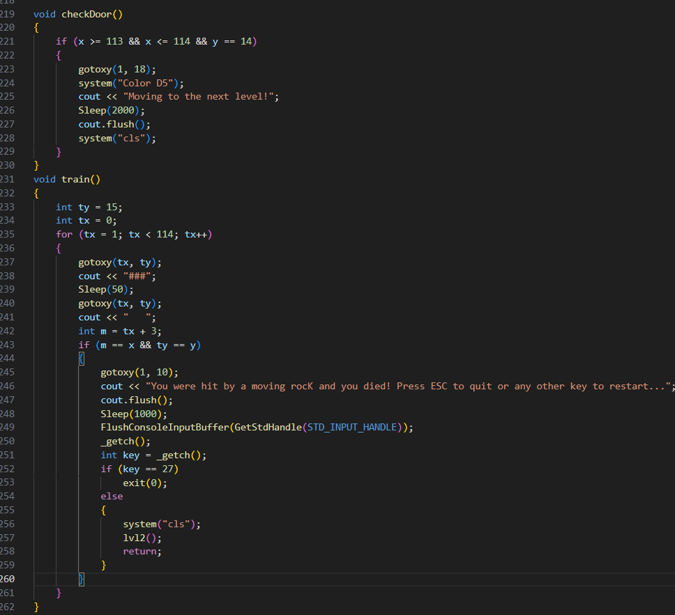
Level Devil Gameplay: Level 2 Function
DescriptionThis C++ code segment defines the lvl2() function for "Level Devil Gameplay," a 2D console-based platformer. It manages the entire gameplay loop for Level 2, initializing the environment, handling player movement, obstacles, and level completion, while introducing new challenges like a falling rock.lvl2() Function:
Initializes Level 2 by resetting the player’s position to (x=1, y=15), calling maze2() to draw the Level 2 environment, and displaying "LVL 2" at (1, 5). It renders the player ("@") with printQ(). A falling rock is set at a fixed x-coordinate (rockX=35) starting at rockY=4. The function runs a nested while loop that:Calls train() to animate a moving obstacle across y=15.Runs a for loop (15 iterations) to handle:Player movement (movement()), with a 50ms delay (Sleep(50)).Hole triggers (triggerHole()) and fall detection (checkFall()).Door checking (checkDoor()) for level progression.Falling rock animation: Erases the rock at its current position, moves it down (rockY++), draws it as "###" at the new position, and resets it to rockY=4 if it passes y=15.Collision detection: If the player’s position (x, y) overlaps with the rock (x=35–37, y=rockY), a game-over message appears, pausing for 1 second. Pressing ESC exits the game; any other key restarts Level 2 by calling lvl2().Checks for level completion: If the player reaches (x=113–114, y=15), it displays "Level 2 complete! Now go to studey game is over." at (1, 18), pauses for 2 seconds, clears the screen, and ends the game.Role: The lvl2() function orchestrates Level 2’s gameplay, integrating movement, dynamic obstacles (train and falling rock), and progression mechanics. It increases difficulty with vertical barriers and additional hazards compared to Level 1
Conclusion: This function drives the core experience of Level 2 in Level Devil Gameplay, managing environment setup, player interaction, and dynamic challenges, showcasing the developer’s skill in creating a cohesive and engaging console-based platformer level.
